Tae Coding

Introduction to Data Science: CS61

Summer 2018

Homework#2

Date Given: June 19, 2018 Due Date:

=======================================================================

**Problem#1**

Write Python code for the following problem.

Toss two dice and add the numbers obtained. The sum of the numbers would be between 2 and 12.

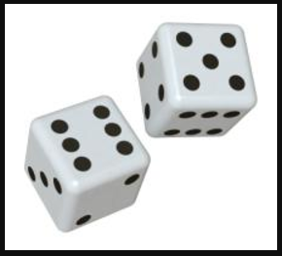 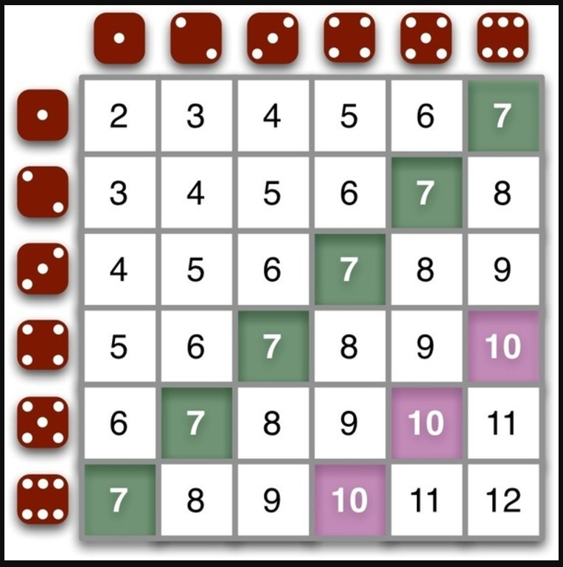

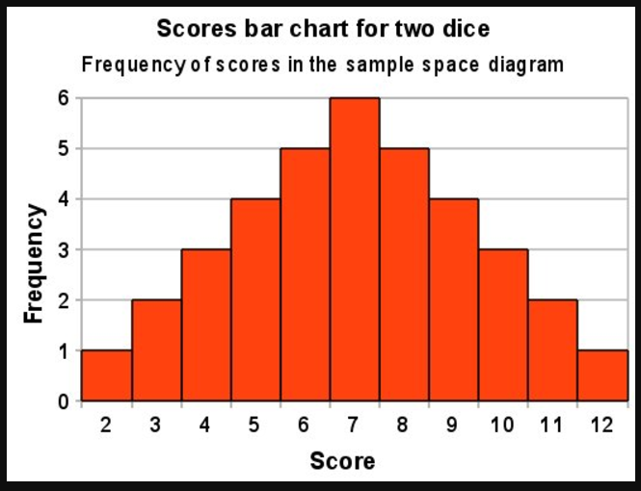

2 dice are tossed

P(Die1+Die2=2)=1/36

P(Die1+Die2=3)=2/36

P(Die1+Die2=4)=3/36

P(Die1+Die2=5)=4/36

P(Die1+Die2=6)=5/36

P(Die1+Die2=7)=6/36

P(Die1+Die2=8)=5/36

P(Die1+Die2=9)=4/36

P(Die1+Die2=10)=3/36

P(Die1+Die2=11)=2/36

P(Die1+Die2=12)=1/36

Repeat this experiment 10,000 time. Compute the probability of getting a sum from 2 – 12.

**Problem#2**

Create a file of 10 observations as shown in the following figure.

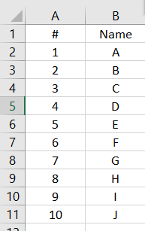

Split the 10 observations in to training and testing samples. The training dataset should have randomly selected 7 observations. The testing dataset should have the remaining 3 observations.